Network Security 1 Project Rubric 2

Design Network Protocols and Architectures

1. Assignment Overview
The purpose of this assignment is to design a small, secure network architecture and demonstrate how network communication operates through the OSI model and TCP/IP model. The design includes one end device, one subnet, IP addressing, subnetting information, network infrastructure, and security protocols.
The proposed network uses a star topology, where the client device connects to a central network switch. A firewall provides protection between the internal network and the Internet.

2. Network Architecture Diagram
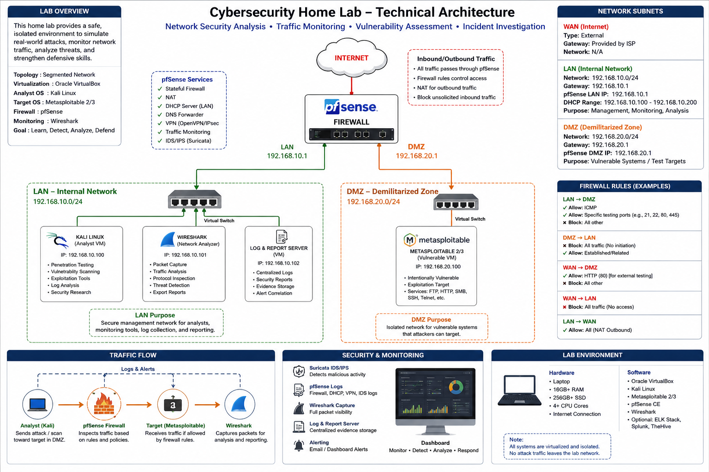
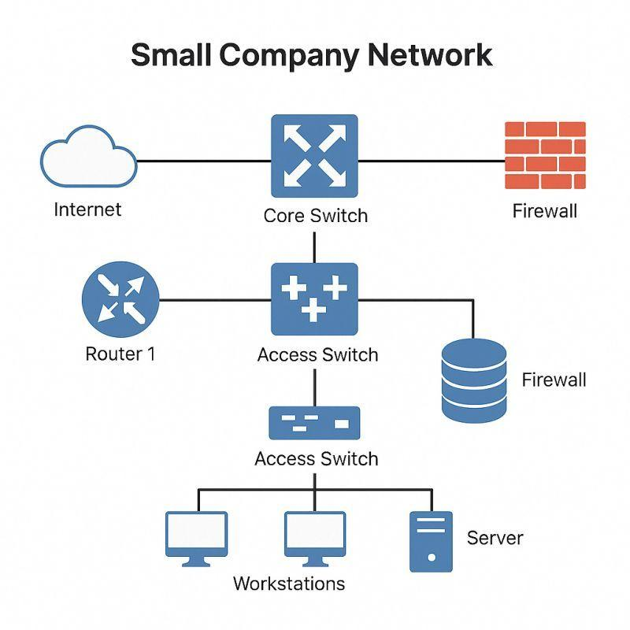
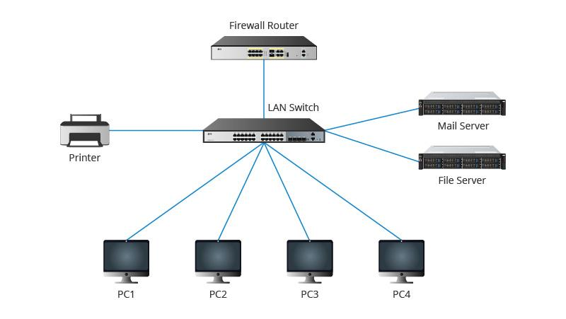
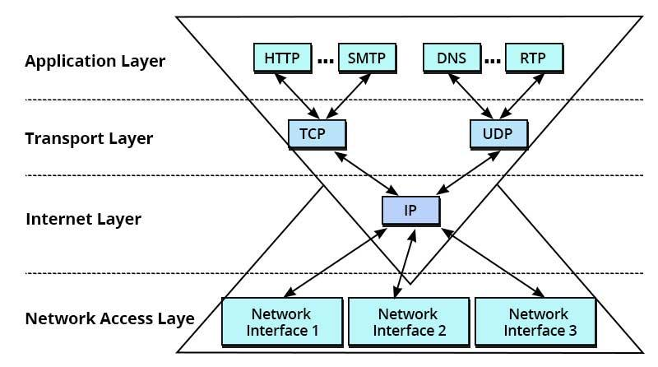
6
A professional version of the architecture can be represented as:
INTERNET
|
|
┌───────────────┐
│ FIREWALL │
│ ACL / IPS │
└───────┬───────┘
|
192.168.10.1
|
┌───────▼───────┐
│ SWITCH │
│ VLAN/LAN │
└───────┬───────┘
|
192.168.10.10
|
┌───────▼───────┐
│ CLIENT PC │
│ 1 DEVICE │
└───────────────┘

Network characteristics
- Topology: Star
- Network: 192.168.10.0/24
- Default gateway: 192.168.10.1
- Client IP: 192.168.10.10
- Subnet mask: 255.255.255.0
- Firewall: Controls traffic entering and leaving the network
- Switch: Connects the client to the internal network

3. Subnetting Design
For this assignment, the network will use the IPv4 network:
192.168.10.0/24
The /24 prefix means that the first 24 bits identify the network, leaving 8 bits for hosts.

Subnet Information
Parameter | Value
Network Address | 192.168.10.0
CIDR | /24
Subnet Mask | 255.255.255.0
First Usable Address | 192.168.10.1
Last Usable Address | 192.168.10.254
Broadcast Address | 192.168.10.255
Total Addresses | 256
Usable Host Addresses | 254
Default Gateway | 192.168.10.1
Client Device | 192.168.10.10

Subnet Calculation
IPv4 addresses contain 32 bits.
For /24:
Network bits = 24
Host bits = 32 - 24
= 8 host bits
Number of addresses:
2^8 = 256 total addresses
Two addresses are reserved:
- Network address: 192.168.10.0
- Broadcast address: 192.168.10.255
Therefore:
256 - 2 = 254 usable host addresses

4. One-Device Network Communication
The assignment specifically requires the OSI and TCP/IP models for one device.
The selected device is:
Client PC — 192.168.10.10
When the client accesses a secure website, data moves down through the networking layers before being transmitted across the network.
For example:
Client PC
192.168.10.10
|
▼
Application
HTTPS
|
▼
Transport
TCP
|
▼
Internet
IPv4
|
▼
Network Access
Ethernet
|
▼
Physical Network

5. OSI Model
The Open Systems Interconnection (OSI) model divides network communication into seven layers.
Layer | Name | Function | Example
7 | Application | Provides network services to applications | HTTPS, DNS
6 | Presentation | Handles encryption, formatting, and translation | TLS
5 | Session | Establishes and manages communication sessions | Session management
4 | Transport | Provides end-to-end communication | TCP, UDP
3 | Network | Provides logical addressing and routing | IPv4, IPv6
2 | Data Link | Provides frame delivery and MAC addressing | Ethernet
1 | Physical | Transmits bits over the physical medium | Ethernet cable

Example
When the client visits an HTTPS website:
Layer 7 – Application:
The web browser uses HTTPS to communicate with the web server.
Layer 6 – Presentation:
TLS provides encryption and helps protect the confidentiality and integrity of the data.
Layer 5 – Session:
The communication session is established and maintained.
Layer 4 – Transport:
TCP provides reliable delivery of the data.
Layer 3 – Network:
IPv4 provides the source and destination IP addresses.
Layer 2 – Data Link:
Ethernet uses MAC addresses to deliver frames across the local network.
Layer 1 – Physical:
The electrical, optical, or radio signals carry the actual bits.

6. TCP/IP Model
The TCP/IP model is commonly represented using four layers.
TCP/IP Layer | Function | Example
Application | Provides application-level network services | HTTPS, DNS, SSH
Transport | Provides end-to-end communication | TCP, UDP
Internet | Provides logical addressing and routing | IPv4, IPv6, ICMP
Network Access | Handles local network communication | Ethernet, Wi-Fi

OSI-to-TCP/IP Mapping

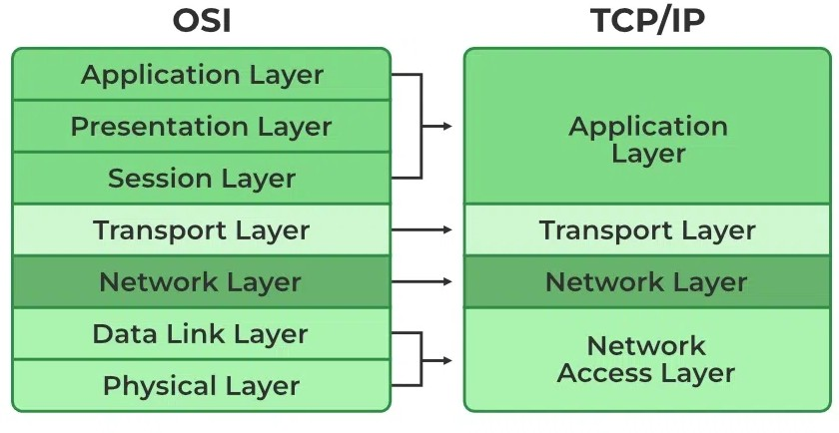

7. Security Architecture
The network should use multiple layers of security rather than rely on a single security mechanism.
This approach is known as Defense in Depth. Relying on a single security mechanism creates a single point of failure—if an attacker bypasses that one barrier, they gain unrestricted access to the entire network. Layered security ensures that if one mechanism fails, subsequent layers continue to contain, delay, or block the threat.
Key Principles of Layered Security
- Redundancy: Multiple controls guard against the failure or compromise of any single safeguard (e.g., a firewall bypass combined with strong host endpoint protection).
- Diversity of Controls: Using different security vendors, technologies, and methods prevents a single flaw or exploit from compromise across all systems.
- Least Privilege & Segmentation: Micro-segmenting networks ensures that an intrusion into one segment does not grant lateral movement to critical core infrastructure.
Core Layers of Network Security
Layer | Primary Function | Core Tools & Technologies
Perimeter / Edge | Filters external traffic entering the network. | Next-Gen Firewalls (NGFW), Edge Routers, DDoS Protection.
Network / Transit | Controls internal traffic flow and segments data. | VLANs, Micro-segmentation, Intrusion Prevention Systems (IPS).
Endpoint / Host | Secures individual devices connected to the network. | EDR/XDR, Antivirus, Patch Management, Host Firewalls.
Identity & Access | Verifies user identity and permissions before granting access. | Multi-Factor Authentication (MFA), Zero Trust Architecture, SSO.
Data Security | Protects sensitive information at rest and in transit. | TLS/SSL Encryption, VPNs, Data Loss Prevention (DLP).
How Defense in Depth Works in Practice
- Phishing Attack Mitigation: An employee clicks a malicious email link. The firewall blocks the command-and-control server connection; even if that fails, endpoint protection detects execution, and multi-factor authentication prevents credential abuse on corporate applications.
- Insider Threat Containment: If a user account is compromised, network micro-segmentation limits the compromised credentials from accessing sensitive databases outside their designated role.

Security protocols and controls
HTTPS/TLS
Protects web communications by encrypting data between the client and web server.
SSH
Provides encrypted remote administration instead of insecure protocols such as Telnet.
IPsec
Can provide encryption and authentication for IP communications, particularly VPN connections.
802.1X
Provides port-based network access control and authentication before allowing a device onto the network.
Firewall ACLs
Access Control Lists can restrict which traffic is permitted or denied based on factors such as IP addresses, ports, and protocols.
IDS/IPS
An Intrusion Detection/Prevention System can identify suspicious network activity and, when configured for prevention, block certain malicious traffic.

8. Security Controls by Layer
OSI Layer | Security Example
Application | HTTPS, TLS, secure DNS
Presentation | TLS encryption
Session | Session authentication and timeout
Transport | TCP controls and firewall port filtering
Network | IPsec, firewall rules, ACLs
Data Link | 802.1X, MAC security, VLAN controls
Physical | Locked equipment, cable security, restricted access
This demonstrates defense in depth, where multiple security mechanisms protect different parts of the communication process.

9. Example Communication
Consider the client accessing:
https://example.com
The communication process can be simplified as:
CLIENT PC
192.168.10.10
|
| HTTPS
▼
TCP
|
| IPv4
▼
192.168.10.1
|
| Firewall inspection
▼
INTERNET
|
▼
WEB SERVER
The client first creates application data. The data is then encapsulated as it moves down the networking stack.
Application Data
↓
TCP Segment
↓
IP Packet
↓
Ethernet Frame
↓
Bits
At the receiving device, the process occurs in reverse, known as decapsulation.

10. Network Security Requirements
The proposed architecture should implement the following security requirements:
- Confidentiality — protect data from unauthorized access using encryption such as TLS.
- Integrity — prevent unauthorized modification of data.
- Authentication — verify users and devices before granting access.
- Authorization — ensure users can access only permitted resources.
- Availability — protect network services against disruption.
- Network segmentation — separate network resources where appropriate.
- Traffic filtering — use firewall rules and ACLs to restrict unauthorized traffic.
- Secure administration — use SSH instead of insecure remote-management protocols.

11. Final Architecture Summary
The proposed network uses a star topology with a firewall protecting the internal network from the Internet. The network uses the 192.168.10.0/24 subnet, with the client device assigned 192.168.10.10 and the firewall serving as the 192.168.10.1 default gateway.
The design demonstrates how communication from the client travels through the seven OSI layers and the four TCP/IP layers. Security is implemented using technologies and protocols such as TLS/HTTPS, SSH, IPsec, 802.1X, firewall ACLs, and IDS/IPS.
This architecture demonstrates the relationship between network protocols, addressing, network architecture, and security controls while providing a simple model that can be expanded into a larger enterprise network.

